**Building A Restaurant Website With Bootstrap**

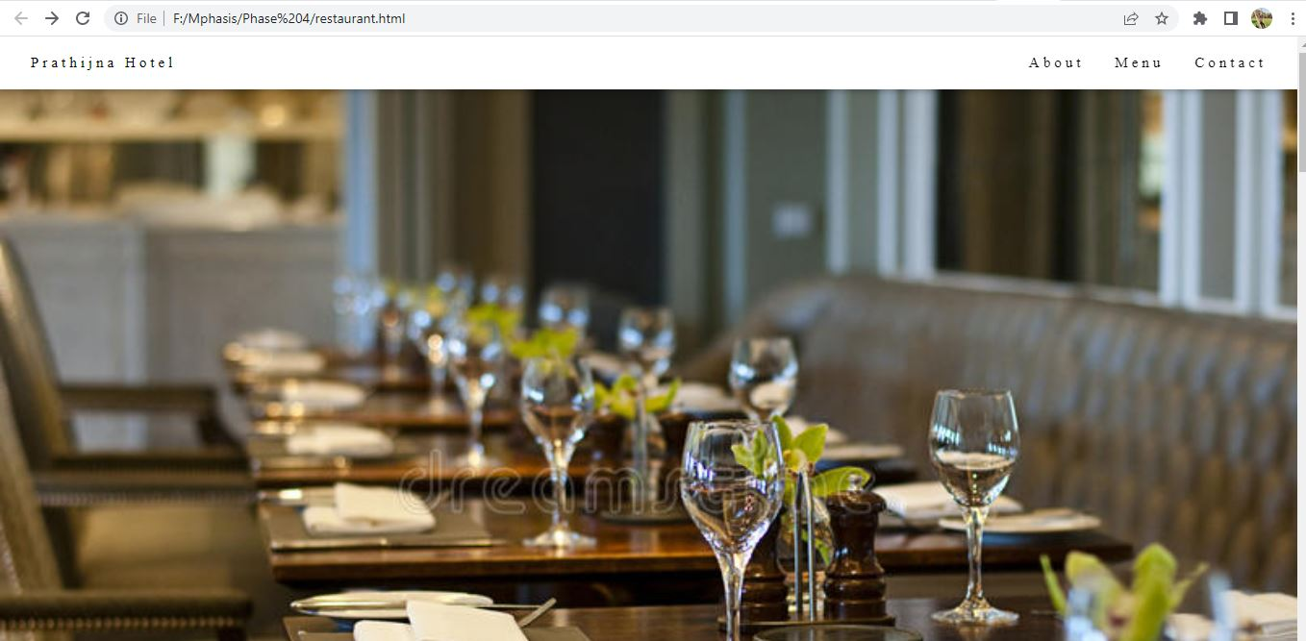

* Above is the home page of the website.

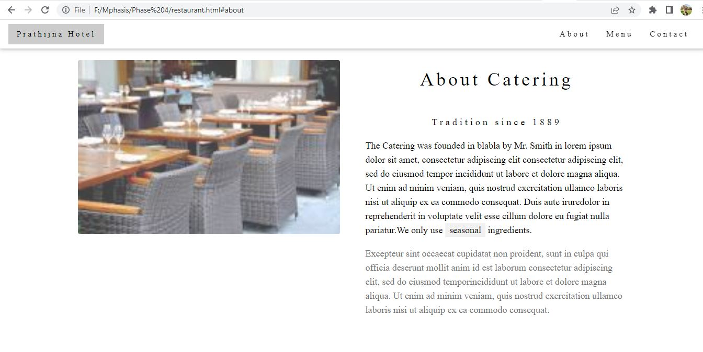

* Above is the about page in the website

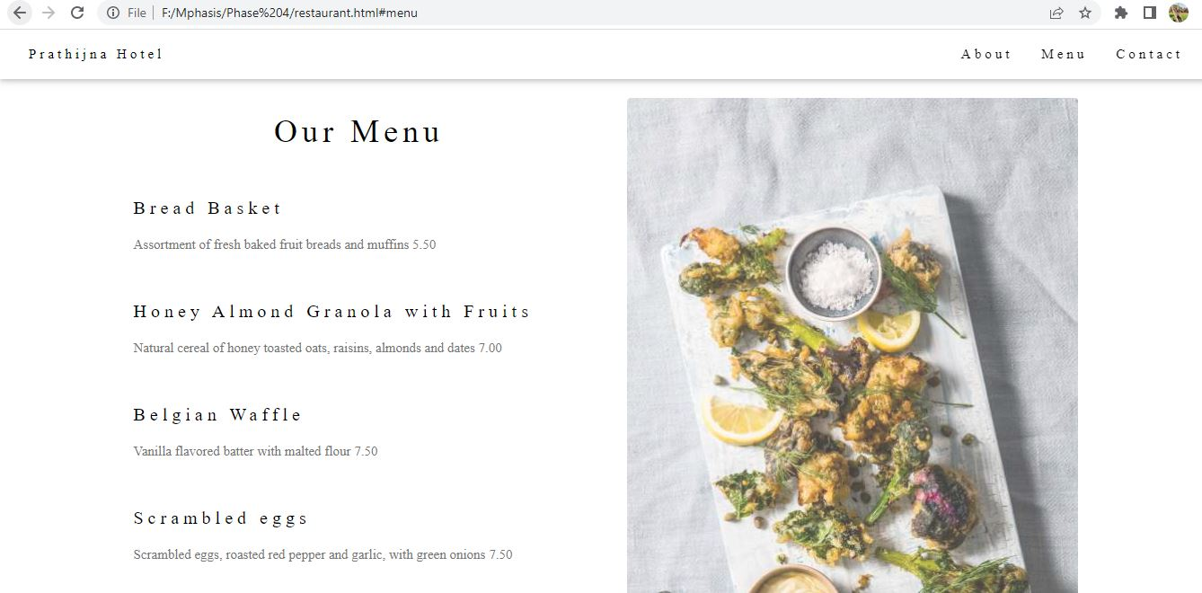

* Above is the menu that are available in the restaurant.

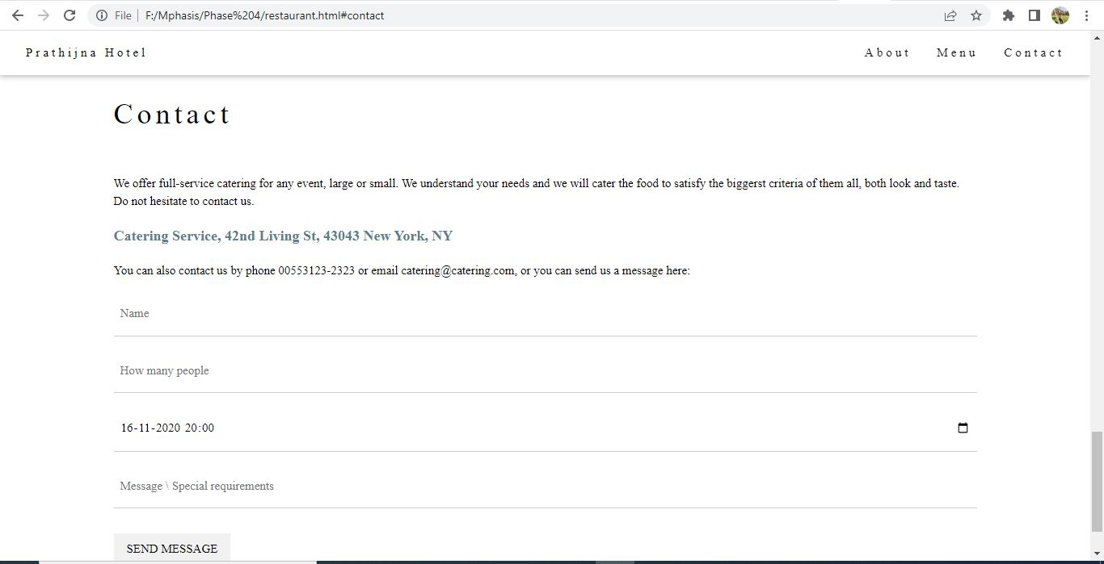

* Customers can book the table by entering the details and can send message.

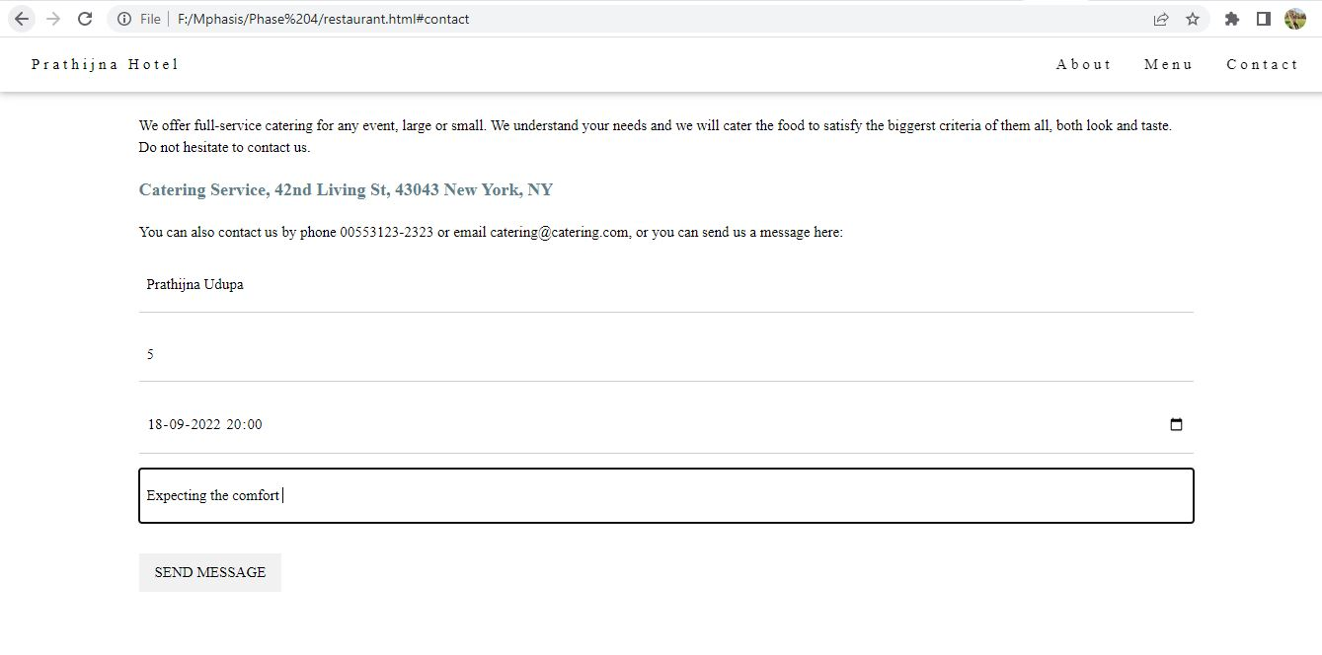

* Details to book the table are entered.